BASH SCRIPT -01
Create a test file and add the script for what commands
You want to see…
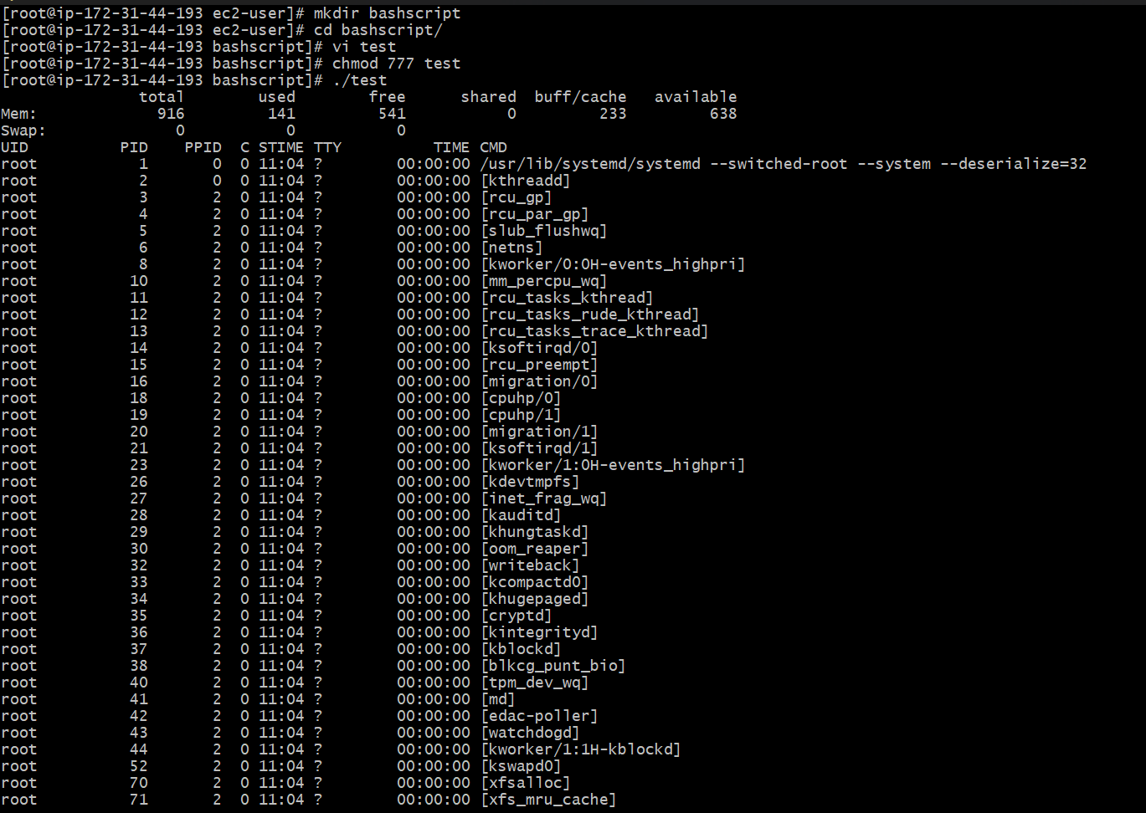
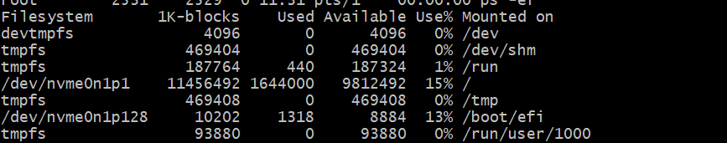
Using command echo $0 for which shell we are using presently
and to check what shells we have in machine use command
cat /etc/shells to check the list of the shells….
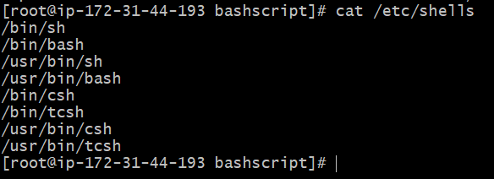
To check which user is using which shell we have a command
Cat/etc/passwd
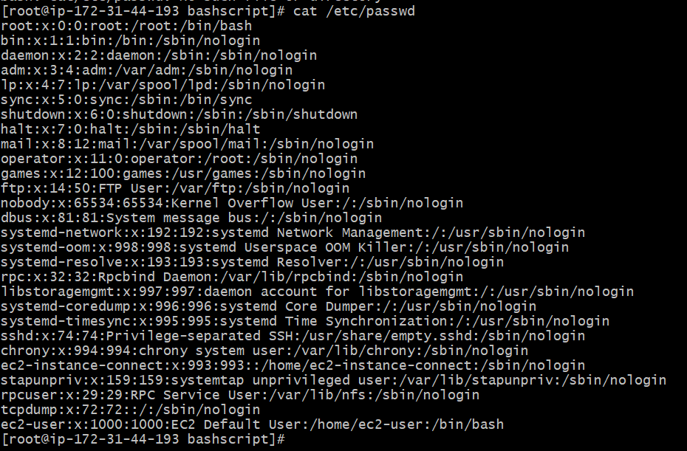
If we want to switch to a different shell then we can use command for example I am using sh it will change to sh shell and for exit from that shell we can use exit
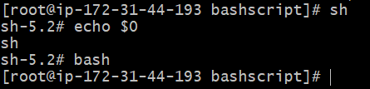
So far executing the file I created directory and sub directory using the command mkdir -p/hemanth/scripts and created a test file using nano and change thew permissions chmod 777 file name….
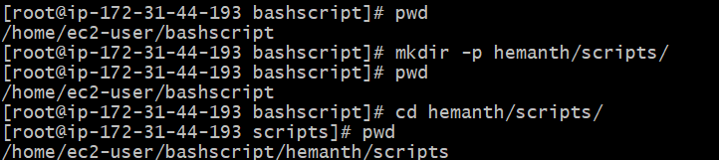
To execute the script name ./script name or bash script name

Always store the scripts in specific folder
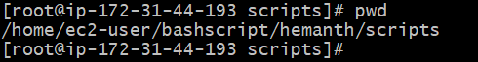
Always make sure to use proper conventions
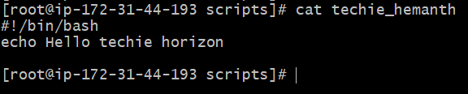
Always end the file name with the script u write so that will be easy for the other user or in the future.so that the user understand which shell has been used…
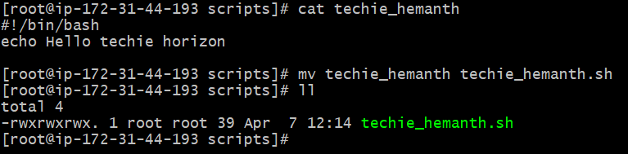
Write a script in bash
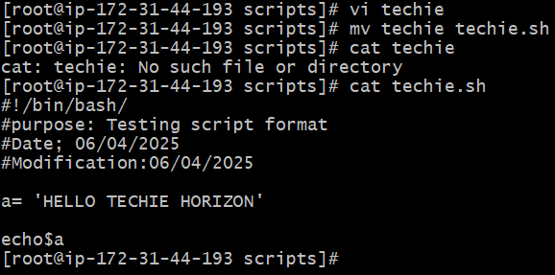

Basic script:
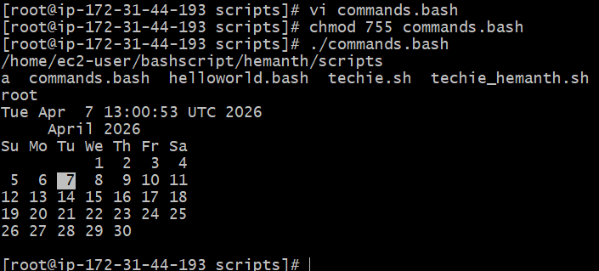
Basic administration task:
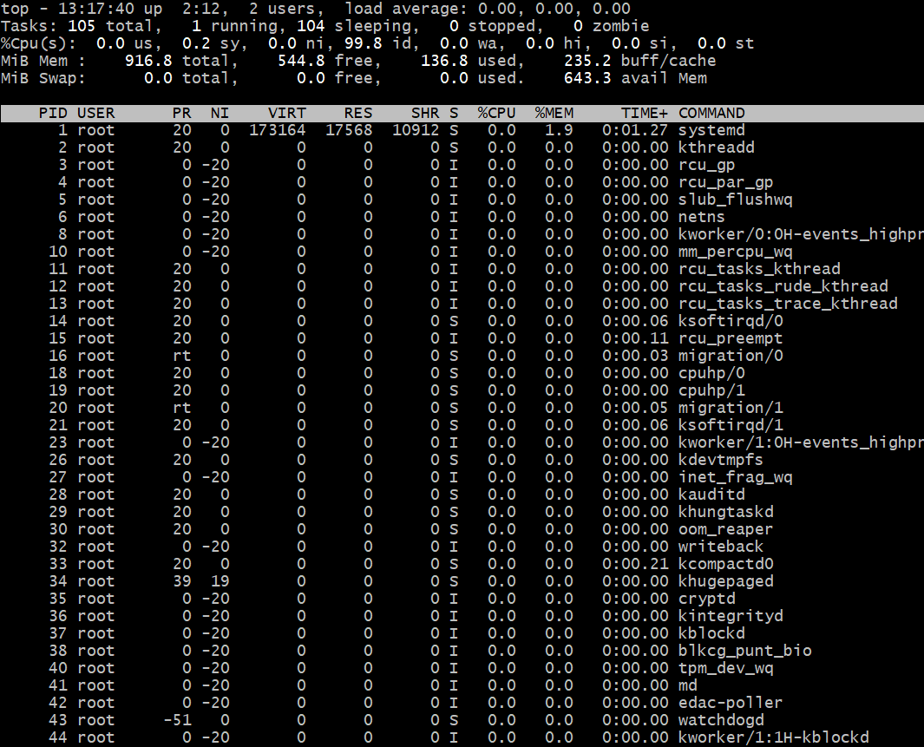
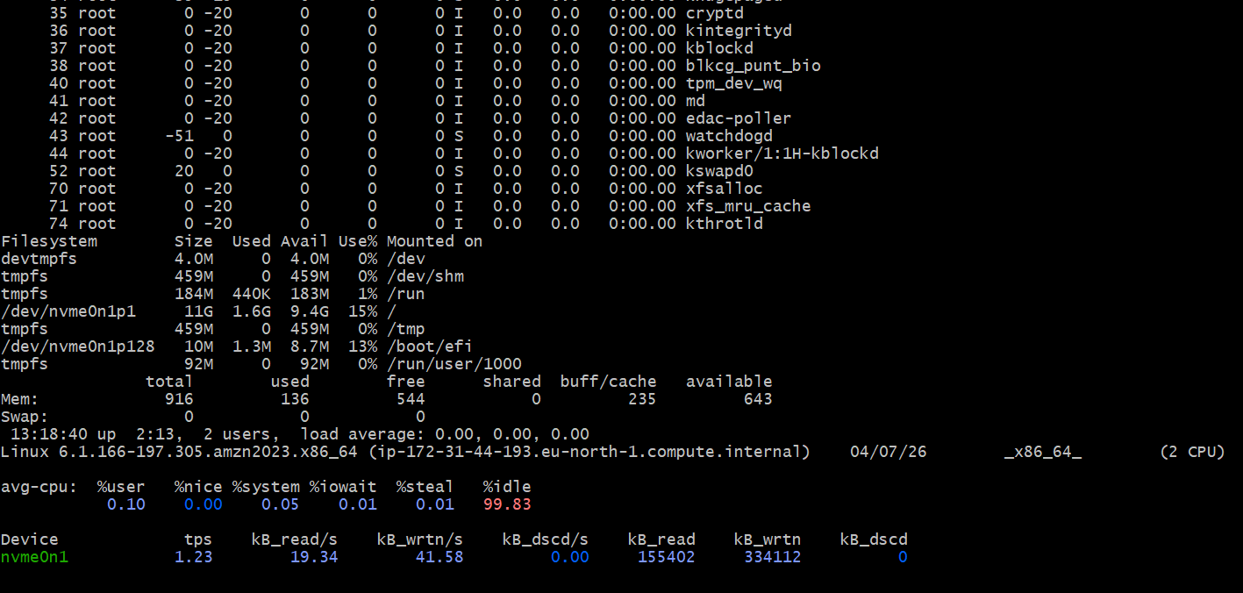
Top | head -10
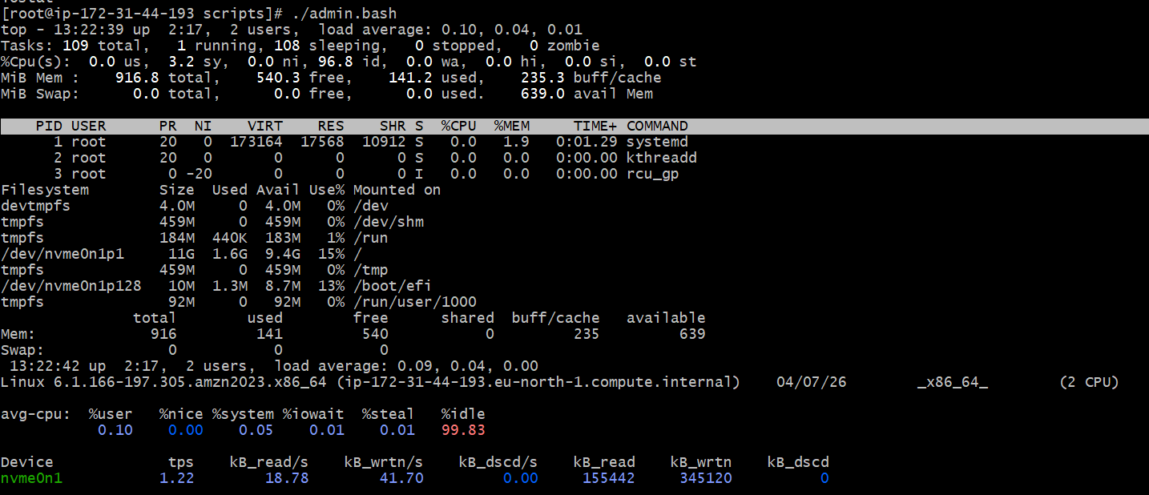
Variables scripts :
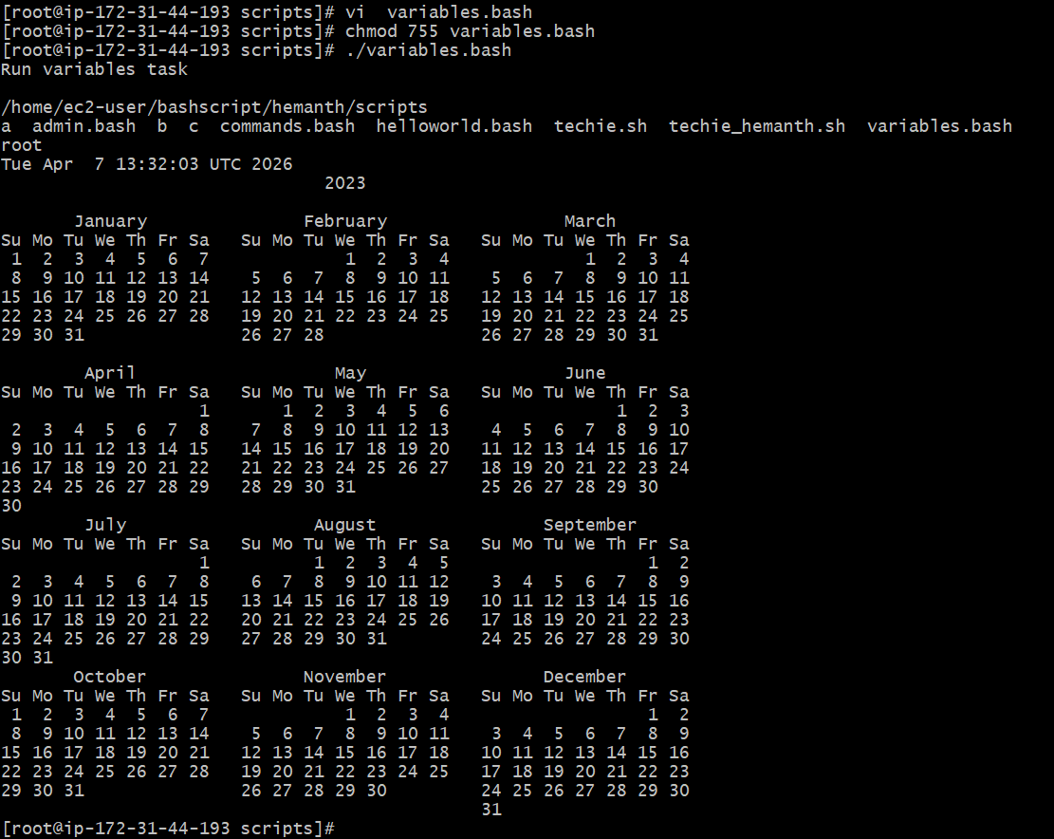

Input and output scripts:
